Julie Mammen

DATA 3320

Seattle-Weather Report

04/13/2023

Does it Rain More in Seattle or St. Louis?

The purpose of this project is to compare the weather data sets from Saint Louis, MO and Seattle, WA. Through this comparison we can understand whether it rains more in Seattle compared to Saint Louis or not, and be able to effectively communicate this comparison in weather between the two cities. We aim to answer this question by analyzing data sets of precipitation from 2018-2022 in both Seattle and St. Louis, joining the data sets to be able to more accurately understand what the data narrates and be able to draw out a clear conclusion from it.

The data for this project comes from the NOAA National Centers for Environmental Information, which provides access to many types of environmental data, including records of daily precipitation. We used their website to request records of daily precipitation from Seattle and St. Louis for the last 5 years.

In order to analyze the data and be able to draw a conclusion, we need to prepare the data and clean it up first. It will be easier to identify and analyze the results if the data sets are joined together as opposed to two separate data frames. Before joining the data sets we want to look at only the data regarding the dates, station, and precipitation. From here, we need to ensure that both data sets are of similar size to ensure that there is no bias in data leaning towards one city or another. We combine the data frames to more easily analyze the data. From here, we have a cleaned up and joined data frame in which we can start to perform analysis to draw out the conclusion about whether it rains more in Seattle or St. louis.

The analysis done on this data set involves looking at the data from daily, monthly, and yearly perspectives. First, we look at the monthly data to see what the average rainfall looks like in both cities to analyze if there are obvious differences or even if there are seasonal differences.

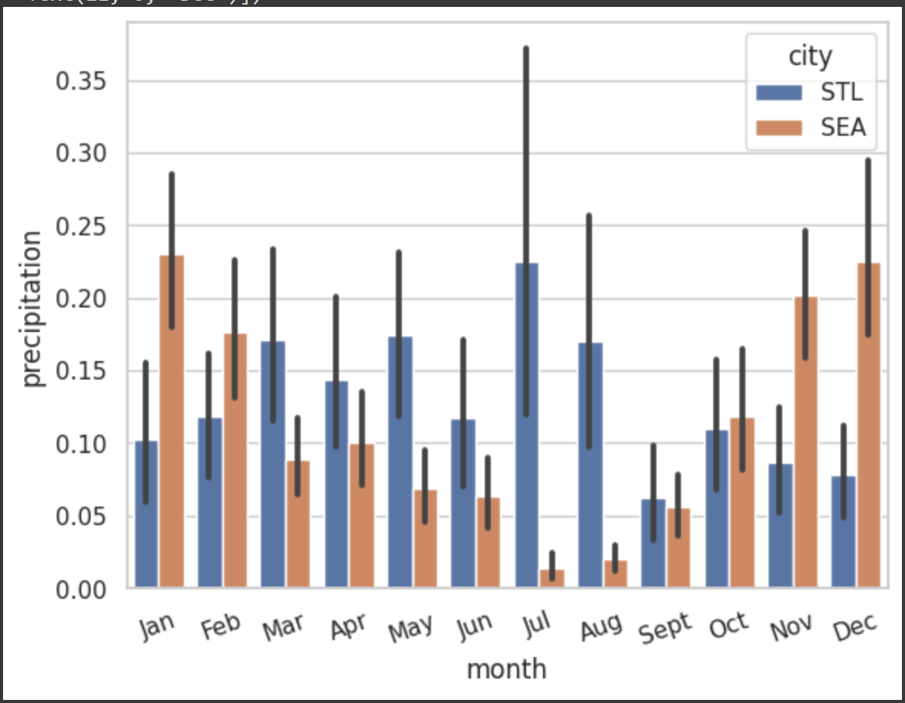

By looking at this graph, it seems to illustrate that on average it rains more monthly in St. Louis. However, we can do some additional analysis to see that it seems to also be related to seasons as well. As seen in the bar graph above, in the months of March to September, it seems to rain more monthly in St. Louis. However, from October to February, it seems to rain more monthly in Seattle. From this, it seems to imply that during Fall/Winter it seems to rain more monthly in September, however, in Spring/Summer, it seems to rain more monthly in St. Louis.

Now, we can look more closely and count how many days of no rainfall there are in both cities.

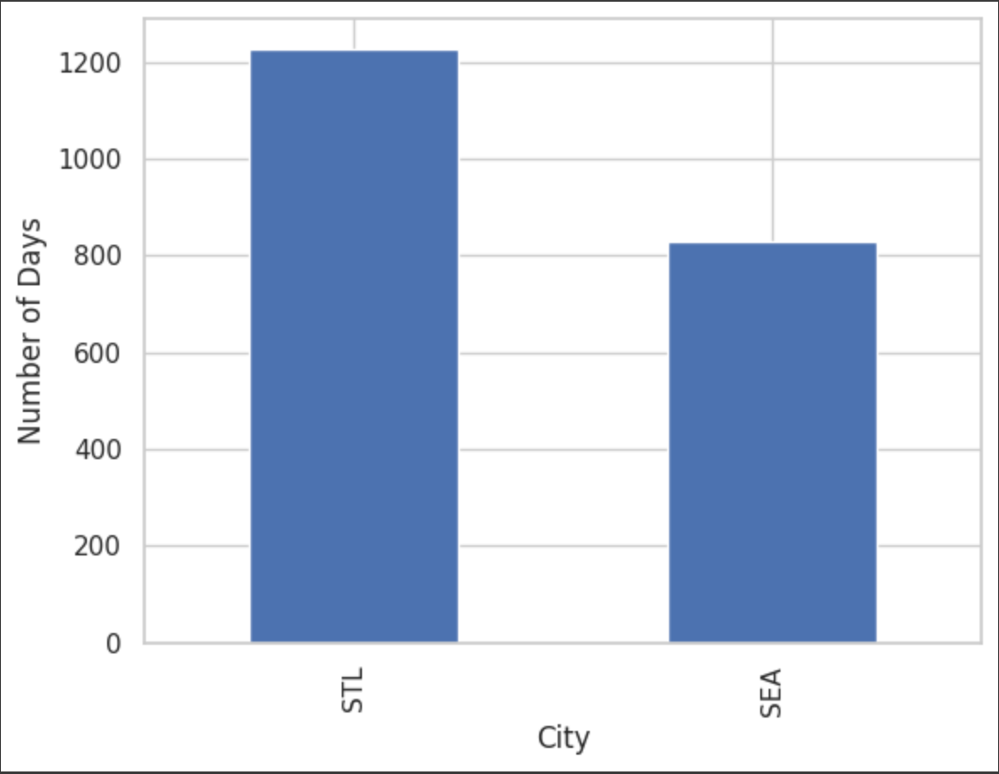

From analyzing this graph, it can be seen that it seems to have fewer days in which it does not rain in Seattle while St. Louis has more days where it does not rain. This seems to insinuate the notion that St. Louis might not be as rainy as Seattle is.

The next step now would be to see how many days it has rained heavily in both cities. This can give a better understanding for us to understand whether it truly rains more on average or if it is instead that perhaps in a given city it might rain less, but when it rains it rains a lot.

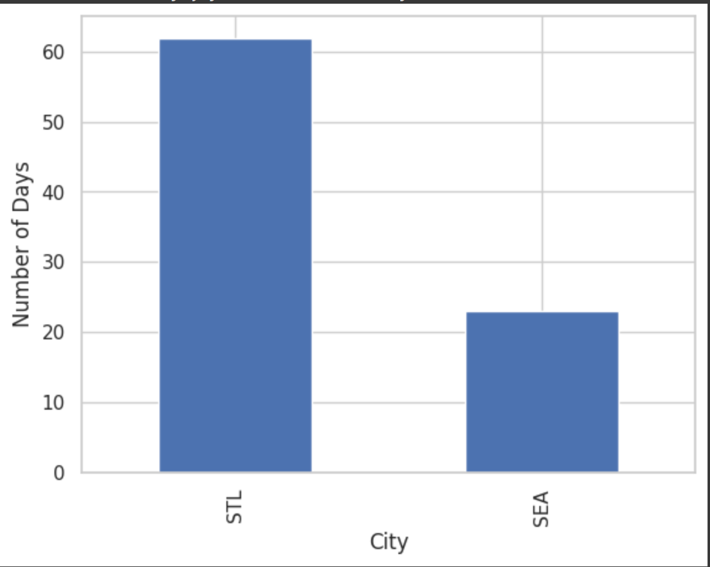

This plot implies much heavier rainfall in St. Louis as the number of days where the precipitation is greater than one inch, is substantially higher than in Seattle.

Therefore, by analyzing all these graphs it can be seen that it perhaps rains more in Seattle, but solely when it comes down to the number of days it rains. However, when analyzing the data there seems to be much heavier rainfall in St. Louis. Therefore, depending on which measure we classify by either side could be argued. Seattle has more consistent rainy days across the years while St. Louis has much more days in which it does not rain, however, when it does rain in St. Louis it typically seems that it tends to rain much harder in St. Louis than in Seattle.